# Performance of Digitally Modulated and Demodulated wireless signal in AWGN Channels vs Fading Channels

**Noise –** unwanted random electrical signals,fluctuating voltages, present in a radio channel that

**Interference –** unwanted received signals at same frequencies

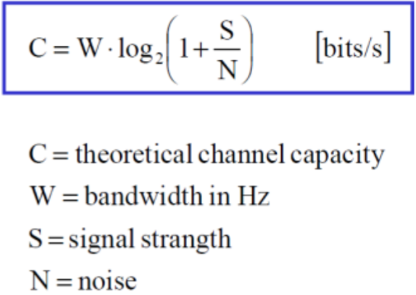Radio Link is extremely critical for wireless communication. System bandwidth and coverage area is limited, noise and interference is added. Thanks to that there is lower throughput, errors happen more frequently, complexity and cost is increased.

**Channel Capacity** is the max data rate at which error-free communication over channel is performed.

## AWGN Channels

**SNR** is calculated as a Power of Received signal devided by bandwidth of complex envelope *u(t)* of transmitted signal times PSD of Noise 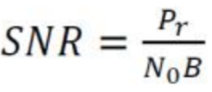

**SINR (Signal to Interferance plus Noise Ratio)** is the same thing but to Noise there is added a power of unwanted received signals at same frequencies *PI.*

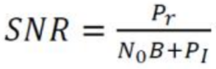

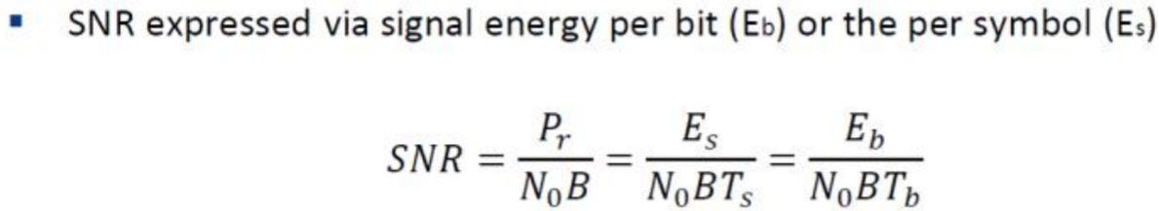

There are also metrics like SNR/symbol and SNR/bit – calculated as an energy of bit or symbol divided by PSD of noise. 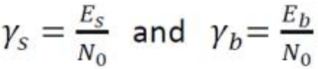 The latter is also used as a general performance measure for AWGN Channel – it is a function of Bit-error-probability *Pb.*

**Bit Error Rating** as a function of SNR/bit is denoted differently across different shift keying schemes.

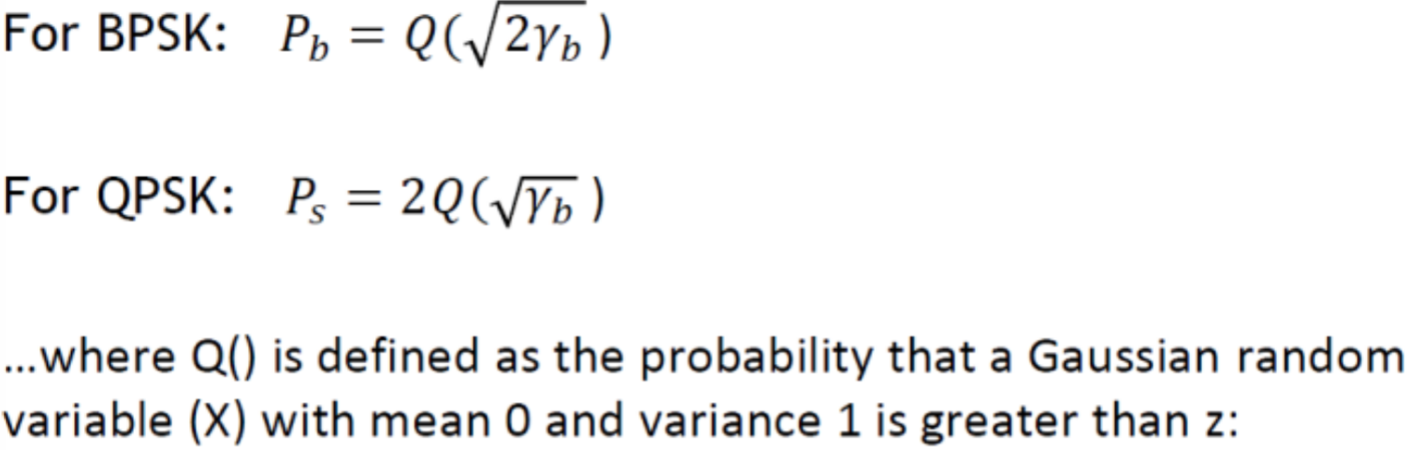 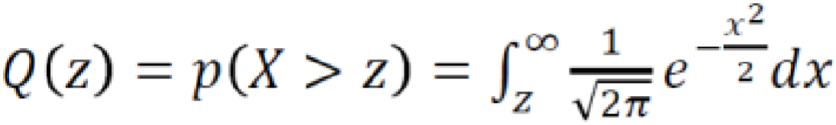

## Fading Channels

In AWGN channel BER depends on SNR but with fading the Power of received signal varies randomly over distance or time. This means *Ps(γs)* with three different performance criteria:

* Outage probability, Pout – probability of SNR falling below maximum allowable Ps
* Average error probability, ‘Ps – averaged over the distribution of γs
* 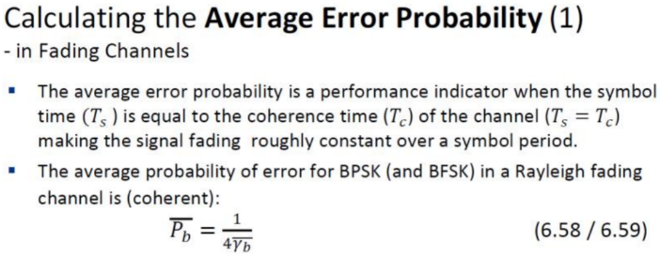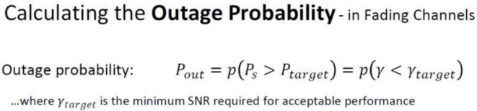Combined AEP and outage

For BPSK, BFSK and DPSK, the BER in AWGN decreases exponentially with increasing SNR

In Fading channels this is only linear, which means that **Power** necessary to maintain given BER is much higher in fading channels than in AWGN channels

## Doppler effect

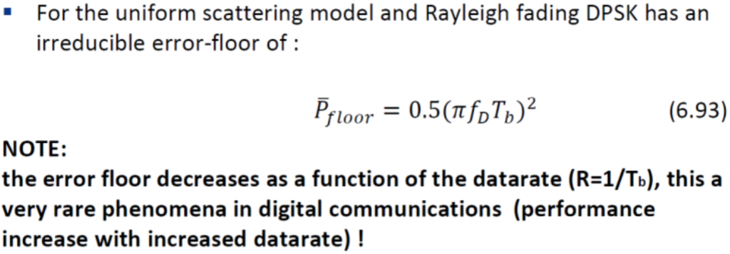High Doppler causes channel phase to de-correlate between symbols, which leads to irreducible error floor for differential modulation and demodulation systems – this means higher power does not reduce errors anymore.

## Inter Symbol Interference effect

Delay Spread that exceeds symbol time causes ISI.

To avoid ISI *Ts >> Tm*

ISI leads to irreducible error floor as increasing the signal power increases the ISI power as well.

### Main Points

In fading Ps is a random variable, characterized by average error probability, outage, or combined

* Alternate Q function approach simplifies Ps calculation

Doppler Spread only impacts differential modulation causing an irreducible error floor at low data rates

Delay Spread causes irreducible error floor or imposes rate limits from ISI

To make wireless communication system offering both mobility and high data-rate we need to combat flat and frequency-selective fading

